Executive Summary – Revenue Decline Analysis

Problem Statement
AtliQ Grands is a hospitality company operating multiple five-star hotels across India. The company is experiencing a decline in revenue and market share in the luxury and business segments due to increasing competition and the absence of data-driven decision making.
To address this issue, business requirements, dashboard mockups, and historical data were provided. The objective of this project is to analyze the given data and develop dashboards that deliver meaningful insights to support strategic and operational decisions.
The initial dashboard mockup shared by the business has been included in this document for reference.

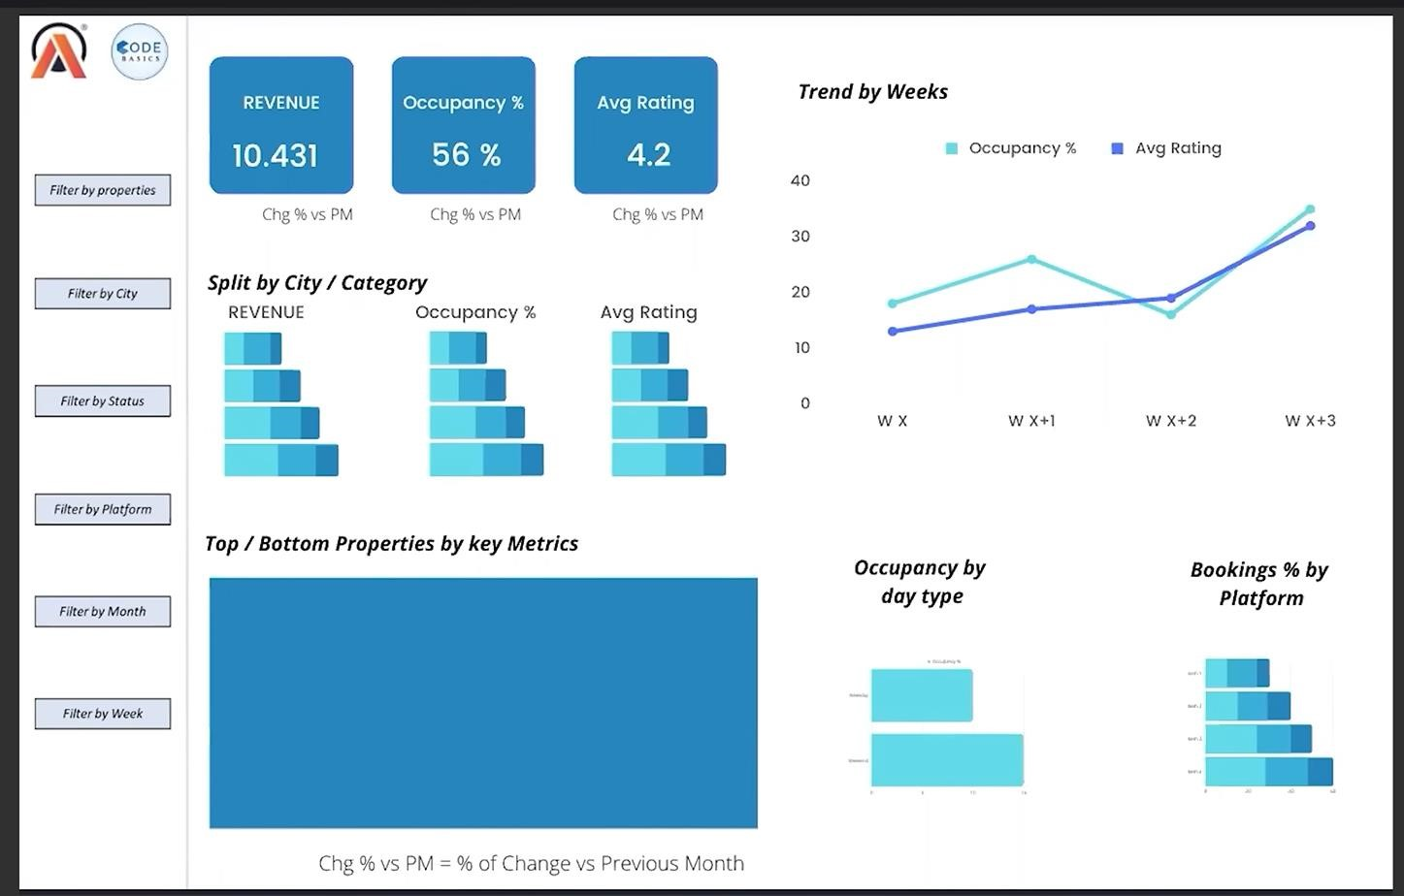
MOCKUP

Revenue Manager Requirements & KPI Definitions
Based on discussions with the Revenue Manager, the following key performance metrics were identified as critical for revenue and occupancy analysis.

Daily Sellable Room Nights (DSRN)
To enable granular analysis, Daily Sellable Room Nights (DSRN) is used.
DSRN helps identify daily room availability trends and provides visibility into maintenancerelated room unavailability.

Key Metric Calculations
- Revenue Per Available Room (RevPAR)
RevPAR = Total Room Revenue / Total Sellable Rooms (SRN)
- Occupancy Percentage (%)
Occupancy % = Total Rooms Occupied / Total Sellable Rooms (SRN)
- Average Daily Rate (ADR)
ADR = Total Room Revenue / Number of Rooms Sold

Room Night Metrics & Booking Realization
Booked Room Nights (BRN)
Booked Room Nights (BRN) represent the total number of room nights that were successfully booked by customers, regardless of whether the customer actually stayed or not.
Example:
If 60 room nights are booked, then BRN = 60.

Utilized Room Nights (URN)
Utilized Room Nights (URN) represent the actual number of room nights that were utilized by customers who checked in and stayed at the hotel.
Example:
Out of 60 bookings, if only 50 customers stayed, then URN = 50.

Realization Ratio
The realization ratio helps measure how many bookings converted into actual stays and highlights cancellations and no-shows.
This metric is critical to understand booking effectiveness and customer behavior.

Weekday vs Weekend Analysis
For this project, hotel performance is analyzed across weekdays and weekends to identify demand patterns.
- Weekdays: Sunday to Thursday
- Weekends: Friday and Saturday (as per hospitality industry standards)
This segmentation helps evaluate occupancy, revenue, and booking behavior differences between weekdays and weekends.

Channel-Level Booking Analysis
Channel-level analysis has been included to understand booking performance across different platforms.
This enables the business to:
- Identify high-performing and low-performing channels
- Analyze cancellation trends by channel
- Optimize distribution and marketing strategies

Business Value
Tracking DSRN ,ADR , realization percentage, weekday vs weekend performance, and channel-level bookings provides a comprehensive view of actual customer stays, improves forecasting accuracy, and supports better revenue and operational decisions.

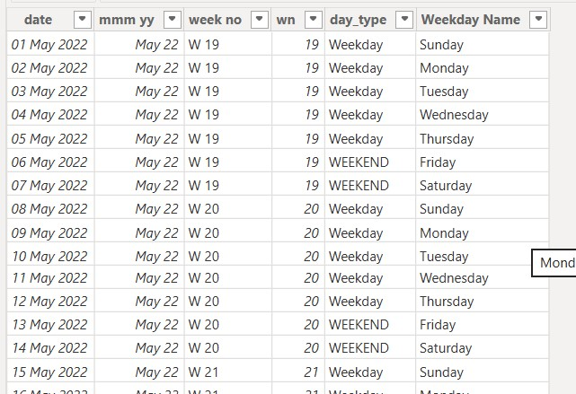
Week Number Assignment Logic
The dataset uses an ISO-based business week mapping. Although 1 May 2022 falls on a Sunday, it is assigned to Week 19 in the dataset. This is because Week 19 represents the business week starting from Monday, 2 May 2022, and the preceding Sunday is grouped with the upcoming business week for consistent weekly reporting.
Week numbers in the dataset follow a year-based calendar system.
Therefore, the same week number appearing across different months represents the same business week, with month labels used only for reporting purposes.
This week-mapping approach ensures uniform aggregation of revenue, occupancy, and booking metrics at a weekly level and is commonly used in analytics and reporting systems.

Time Period: May 2022 – July 2022
Category: Elite Mumbai
Granularity: Weekly Revenue (₹ Millions)

Weekly revenue data was consolidated at the Year–Week level to ensure accurate representation of weekly business performance. This aggregation eliminated duplicate counts caused by month-level splits (e.g., May W23 and June W23 were combined), providing true weekly figures for Aggregated Weekly Revenue (Rounded):
Week | Revenue (M)
W19 | 54
W20 | 50
W21 | 49
W22 | 51
W23 | 49
W24 | 55
W25 | 50
W26 | 47
W27 | 53
W28 | 54
W29 | 49
W30 | 42
W31 | 32

The healthy weekly revenue range was established by analyzing historical weekly revenue and validated statistically using mean and standard deviation. Weeks consistently falling between 48–55 M were considered normal, representing expected performance. Deviations outside this range were flagged for further investigation
Root Cause Analysis – Occupancy Validation
To investigate the revenue decline, Week 31 (₹32 M) was compared against a normal reference week (Week 28, ₹54 M), which falls within the established healthy revenue range and represents typical business performance for the Elite Mumbai – Luxury category.

Key Observation 1: Occupancy %
- Week 31 Occupancy: ~51%
- Normal Week (W28) Occupancy: ~61–66%
Insight:
Week 31 experienced a noticeable decline in occupancy compared to the normal reference week, indicating reduced room utilization during the affected period.
However, further analysis shows that similar occupancy levels (~51%) were also observed in other weeks (W21, W23, W26, W30), where revenue impact was comparatively moderate and did not always result in a severe drop.
Conclusion:
This indicates that lower occupancy is a contributing factor, but not the sole driver of the sharp revenue decline in Week 31. The severity of the revenue dip suggests the presence of additional influencing factors beyond occupancy alone.

Daily sellable room nights (DSRN) remained constant during the critical week, indicating that the revenue dip was not due to room availability but driven by occupancy, realized bookings, or pricing factors.

Booking Realization Analysis
Booking realization was analyzed to determine whether cancellations or no-shows contributed to the observed revenue decline.
The realization ratio (URN / BRN) remained stable throughout the analysis period, ranging between ~69% and 71% across both normal and low-performing weeks.
Notably, the critical week (Week 31) showed a realization rate (~69%) consistent with historical averages, indicating no abnormal increase in cancellations or no-shows.
Conclusion: Booking realization was not a contributing factor to the revenue decline, and the issue lies elsewhere in the revenue generation process.
Since occupancy, realization, and ADR remained largely stable across both normal and affected weeks, further analysis was conducted at the segment level to identify shifts in revenue contribution.
Segment-wise revenue trends revealed a significant decline in the Luxury segment, where weekly revenue dropped from approximately ₹31 M to ₹17 M toward the latter part of the analysis period.
This sharp decline in luxury revenue explains the overall revenue drop observed at the aggregate level, despite stable operational KPIs.
Conclusion: The revenue decline is primarily driven by reduced contribution from the Luxury segment rather than changes in occupancy, pricing, or booking realization.

The Luxury segment was selected for deeper analysis as it exhibited the most pronounced revenue decline compared to other segments, making it the primary contributor to the overall revenue drop.
A weekday vs weekend analysis was conducted by aggregating data across May–July to understand demand and pricing behavior.
Weekends showed higher occupancy (64%) compared to weekdays (57.4%), indicating stronger leisure demand. However, average daily rates remained nearly identical across both periods (~₹15.2K).
As a result, weekend revenue (₹20,582) did not surpass weekday revenue (₹22,519), despite better room utilization.

CONCLUSION
The revenue decline observed during the analysis period is not driven by operational constraints such as room availability or booking realization. Daily Sellable Room Nights (DSRN) remained constant, and booking realization percentages stayed stable (~69–71%) across both normal and low-performing weeks, ruling out cancellations or inventory issues as primary causes.

While lower occupancy was observed in the critical week (Week 31), similar occupancy levels were also present in other weeks without a proportionate revenue impact. This indicates that occupancy alone does not fully explain the severity of the revenue drop.
Further investigation at the segment level revealed that the Luxury segment experienced a sharp decline in revenue contribution, making it the primary driver of the overall revenue downturn. This decline occurred despite relatively stable ADR and realization metrics at an aggregate level.

Additionally, weekday vs weekend analysis showed higher weekend occupancy but no corresponding premium pricing, resulting in missed revenue opportunities during high-demand periods. The issue was further compounded by a sudden reduction in ADR within the Offline Direct channel, particularly during June, suggesting a pricing strategy shift that may not have been aligned with demand behavior.

Final Insight
The revenue decline is primarily attributed to suboptimal pricing and revenue optimization strategies within the Luxury segment, rather than demand loss, inventory limitations, or booking inefficiencies. Addressing pricing alignment, especially during weekends and across key channels, presents a significant opportunity for revenue recovery and growth.

